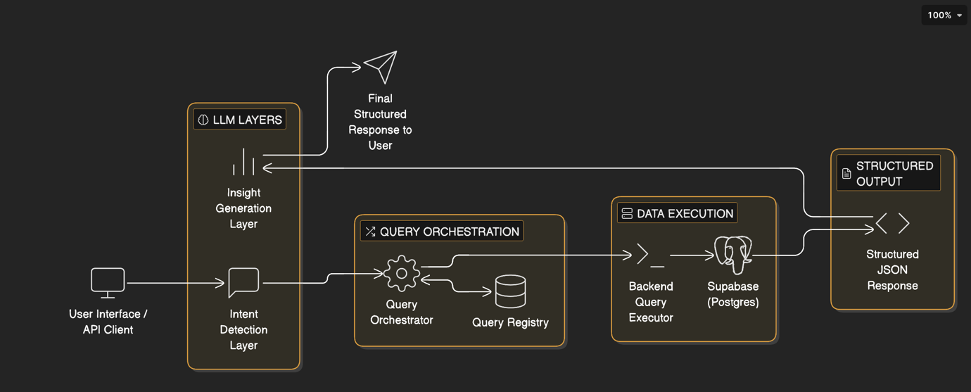

AI Agent Architecture Explanation

GTM Intelligence System Design

Why I Selected This Design
I selected this layered architecture to achieve four critical objectives:
- Security First
- Predictable Performance
- Controlled AI behaviours
- Enterprise Scalability
Instead of allowing the AI model to directly query the database, we separated responsibilities across clearly defined layers. This prevents misuse, ensures consistency, and guarantees production-grade reliability.

Layer-by-Layer Explanation

1. User Interface / API Client
This is where users interact with the system:
- Web dashboard
- Internal GTM tools
- API-based integrations
Users ask business questions in natural language.
Example:
“Find teams expanding rapidly in Texas.”

2. LLM Layers
This layer contains two separate responsibilities:

A. Intent Detection Layer
The LLM:
- Understands the user’s question
- Identifies the correct query type
- Extracts parameters (market, timeframe, growth threshold)
It does not:
- Access the database
- Write SQL
- Modify data
It only produces structured instructions like:
{
"query_id": "find_expansion_teams",
"parameters": {
"market": "Texas",
"days_window": 90
}
}

B. Insight Generation Layer
After the database returns structured results, the LLM:
- Summarizes patterns
- Explains business implications
- Adds confidence scoring
- Produces readable insights
Important:
This layer never changes raw data. It only interprets it.

3. Query Orchestration Layer
This is the control center.
It:
- Validates the query_id
- Validates parameters
- Applies limits
- Maps to a predefined SQL template
Why this exists:
- Prevents dynamic SQL generation
- Ensures performance constraints
- Blocks unsafe operations

4. Query Registry
This is a library of pre-approved, optimized queries.
Each entry contains:
- Parameterized SQL
- Allowed filters
- Maximum limits
- Expected output schema
This ensures:
- AI cannot invent new queries
- Business logic remains consistent
- Database schema changes do not break the system

5. Data Execution Layer
The backend executor:
- Uses a secure Service Role key
- Executes parameterized SQL
- Enforces timeouts (<500ms)
- Logs every execution
This layer ensures:
- AI never directly touches the database
- All access is controlled and monitored

6. Supabase (Postgres)
This is the source of truth.
It contains:
- new_unified_agent
- unified_team
- company
- engagement_history
Security mechanisms:
- Indexed columns for fast retrieval
- Row Level Security (RLS)
- Role-based access control
- Optional materialized views

7. Structured Output Layer
The database returns clean JSON:
{
"results": [...],
"metadata": {
"query_time_ms": 240,
"total_results": 38
}
}
This ensures:
- Consistent frontend integration
- Observability
- Auditability

Why This Architecture Is Safer Than Direct AI-to-Database Access
If the AI directly accessed the database:
- It could generate inefficient queries
- It could cause full table scans
- It could accidentally modify data
- It could bypass access rules
- It would be difficult to audit
Our architecture prevents all of this.

Security & Operational Cautions We Follow
This is critical for production-grade AI agents.

1. Read-Only Database Access
The AI Agent:
- Has read-only access
- Cannot INSERT
- Cannot UPDATE
- Cannot DELETE
- Cannot ALTER schema
All write operations are completely disabled for the AI layer.

2. No Dynamic SQL from LLM
We do NOT allow:
- Free-form SQL generation
- Arbitrary query execution
- Schema discovery queries
Only predefined templates are allowed.

3. Parameter Validation
Before execution:
- Validate types
- Enforce numeric ranges
- Enforce maximum limits
- Prevent wide date ranges
- Restrict result size (e.g., max 100 rows)
4. Row-Level Security (RLS)
Even if a query is valid:
- Data visibility is restricted by role
- Market-level or org-level boundaries apply
- AI cannot bypass these controls

5. Statement Timeouts
We enforce:
- Max execution time (e.g., 500ms)
- Prevent runaway queries
- Protect database performance

6. Logging & Monitoring
We log:
- query_id
- parameters
- execution time
- result count
- error rate
- LLM token usage
This ensures:
- Observability
- Audit compliance
- Performance optimization
- Abuse detection

7. No Write Access to Production Data
Even if the AI hallucinated a write command:
- It would fail at permission level
- Backend executor blocks non-SELECT queries
- Database role has no write privileges

Design Philosophy
We intentionally separated:
Responsibility | Layer
Understand question | LLM Intent Layer
Decide which query to run | Orchestration Layer
Execute safely | Backend Executor
Store truth | Database
Explain results | LLM Insight Layer
This separation guarantees:
- Controlled AI behavior
- Enterprise-grade reliability
- Security compliance
- Scalability

Final Summary
This AI Agent architecture was selected because it:
- Prevents unsafe AI behavior
- Enforces structured data access
- Guarantees performance
- Maintains strict read-only access
- Protects production databases
- Provides explainable, structured output
It ensures the AI acts as an intelligent analyst — not as a database operator.

